Phishing Email Detection & Awareness System

Written by: Harneet kour
Cybersecurity Task 2: Future Interns
Table of Contents
1. Executive Summary 3
2. Introduction 3
2.1 Objectives 3
2.2 Scope & Methodology 3
2.3 Tools Used 4
2.4 Ethical Considerations 4
3. Common Phishing Indicators 4
4. Phishing Email Analysis 5
4.1 Sample 1: DHL Shipping Invoice 5
4.1.1 Phishing Email Sample 5
4.1.2 Email Header Analysis (MXToolbox) 5
4.1.2 Email Header Analysis (VirusTotal) 6
4.1.3 Identified Phishing Indicators 7
4.1.4 Phishing Attack Mechanism 7
4.1.5 Potential Security Impact 7
4.1.6 Security Recommendations 7
4.2 Sample 2: Human Resources Department Email 8
4.2.1 Phishing Email Sample 8
4.2.2 Email Header Analysis (MXToolbox) 8
4.2.2 Email Header Analysis (VirusTotal) 9
4.2.3 Identified Phishing Indicators 10
4.2.4 Phishing Attack Mechanism 10
4.2.5 Potential Security Impact 10
4.2.6 Security Recommendations 10
4.3 Sample 3: Fake Outlook Notification 11
4.3.1 Phishing Email Sample 11
4.3.2 Email Header Analysis (MXToolbox) 12
4.3.2 Email Header Analysis (VirusTotal) 12
4.3.3 Identified Phishing Indicators 13
4.3.4 Phishing Attack Mechanism 13
4.3.5 Potential Security Impact 13
4.3.6 Security Recommendations 13
4.4 Sample 4: PayPal Account Restriction Email 14
4.4.1 Phishing Email Sample 14
4.4.2 Email Header Analysis (MXToolbox) 14
4.4.2 Email Header Analysis (VirusTotal) 15
4.4.3 Identified Phishing Indicators 16
4.2.4 Phishing Attack Mechanism 17
4.4.5 Potential Security Impact 17
4.4.6 Security Recommendations 17
5. Phishing Prevention and User Awareness 17
5.1 Prevention Guidelines for Users 17
5.2 Do's and Don'ts for Employees 18
Do's 18
Don'ts 18
6. Conclusion 18

1. Executive Summary
Phishing is a common cyberattack that uses fraudulent emails to trick users into revealing sensitive information, clicking malicious links, or downloading harmful attachments. The purpose of this project is to analyse phishing email samples and identify the techniques used by attackers.
Five phishing email examples were examined and assessed based on common indicators such as suspicious sender addresses, urgent language, misleading links, and requests for personal information. The analysis highlights how cybercriminals use social engineering tactics to deceive users and gain unauthorized access to accounts and data.
The project also outlines key recommendations for recognizing and preventing phishing attacks. By understanding these threats and following cybersecurity best practices, users can better protect themselves from online scams and security breaches.

2. Introduction

2.1 Objectives
- To understand what phishing attacks are and how they operate in real-world scenarios.
- To analyse different phishing email samples and identify common characteristics.
- To recognize social engineering techniques used by attackers to manipulate users.
- To classify phishing emails based on their risk level and severity.
- To improve awareness of cybersecurity threats related to email communication.
- To suggest basic prevention methods to protect users from phishing attacks.

2.2 Scope & Methodology
This project focuses on the identification and analysis of phishing emails used in cyberattacks. It covers common phishing techniques such as fake sender identities, misleading links, urgent messages, and malicious attachments. The study is limited to email-based phishing examples and does not include other forms of cyber threats such as malware or network-based attacks.
The methodology used in this project involves collecting publicly available phishing email samples from trusted cybersecurity sources. Each email is examined to identify suspicious elements such as sender details, message content, embedded links, and attachments. The emails are then analysed to determine their intent and classified based on risk level (low, medium, or high). Finally, findings are summarized to highlight common phishing patterns and provide basic prevention recommendations.

2.3 Tools Used

2.4 Ethical Considerations
- Only publicly available phishing email samples were used for analysis.
- No real personal, confidential, or sensitive user data was collected or used.
- No phishing emails were created, sent, or tested on real individuals.
- All activities were conducted for educational and awareness purposes only.
- No systems, accounts, or networks were accessed without permission.
- The project strictly avoids any actions that could cause harm or security risks.
- Proper care was taken to ensure responsible and ethical use of cybersecurity information.

3. Common Phishing Indicators
Phishing Indicator | Description | Risk Level
Generic greetings | Emails that do not use the recipient’s actual name (e.g., “Dear User”) | Medium
Urgency or fear tactics | Messages that pressure users to act quickly (e.g., account will be locked) | High
Suspicious sender address | Email address that does not match official company domain | High
Fake or misleading links | URLs that look unusual, shortened, or different from the real website | High
Requests for sensitive data | Asking for passwords, OTPs, or banking details | High
Poor grammar and spelling | Unprofessional language or multiple writing errors | Medium
Unexpected attachments | Files that were not requested, especially .zip or .exe formats | High
Unrealistic offers | Messages claiming prizes, refunds, or rewards that seem too good to be true | Low

4. Phishing Email Analysis

4.1 Sample 1: DHL Shipping Invoice
Email Type: Invoice / Delivery Phishing Email
Suspicious Sender Address: returnsupport@securitygateway.com
Email Subject: DHL Shipping Invoice
Threat Assessment: High Risk

4.1.1 Phishing Email Sample
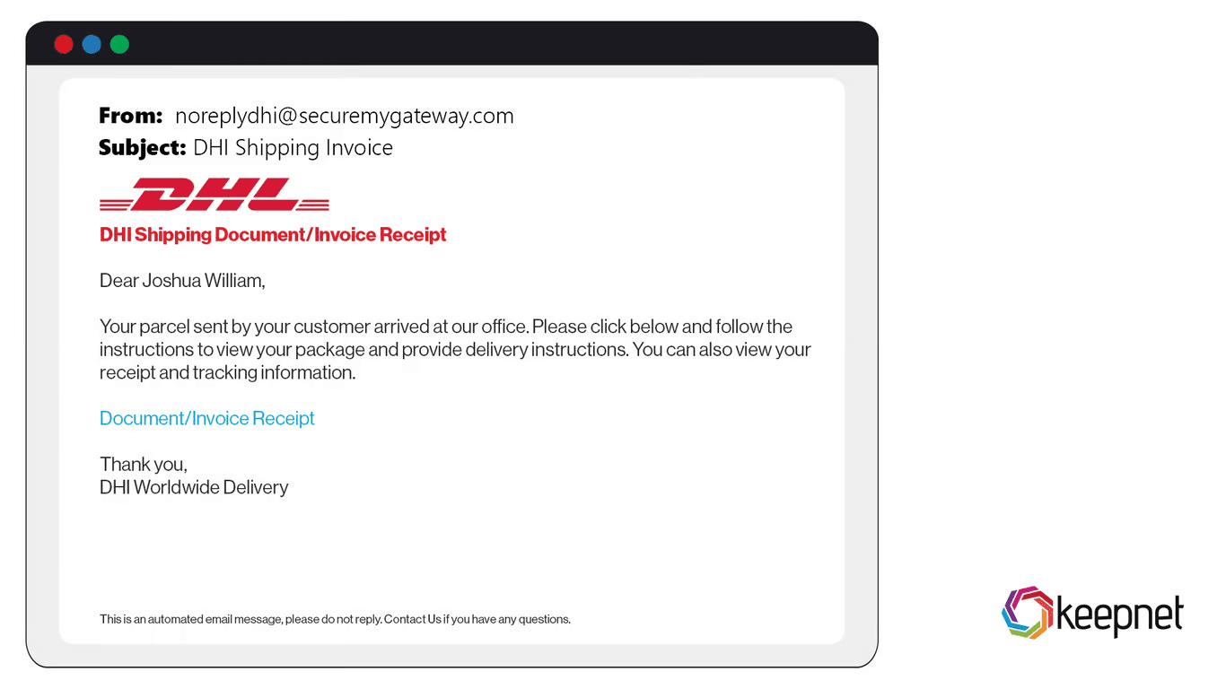
The email claims that a DHL shipment invoice requires immediate review and asks the recipient to open an attached document. The message creates urgency and encourages the user to click on a malicious attachment.

4.1.2 Email Header Analysis (MXToolbox)
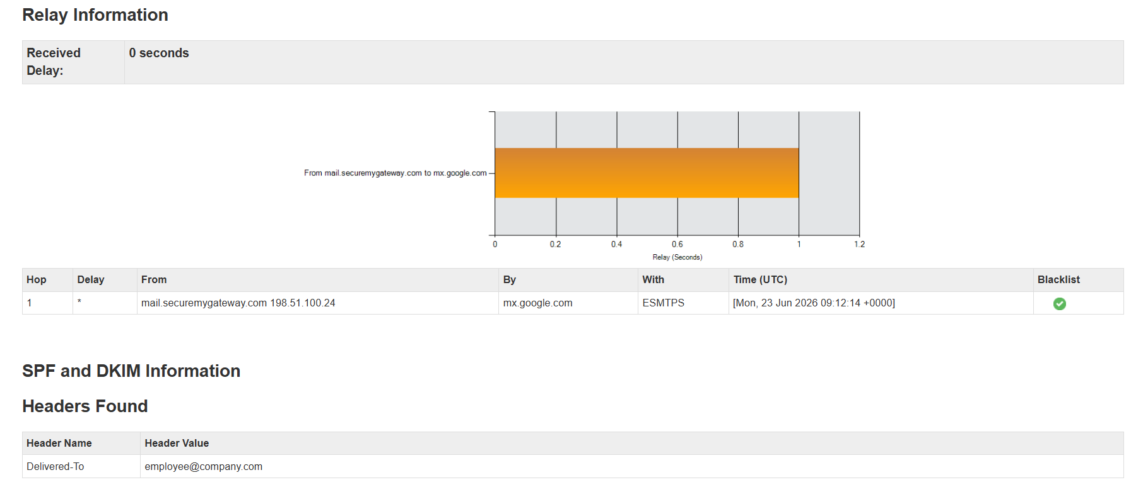
MXToolbox was used to examine the email header information and verify the legitimacy of the sender. Email headers contain technical information about the route taken by an email, including the sender's domain, mail servers, IP addresses, and authentication records.
The analysis revealed inconsistencies between the displayed sender identity and the actual sending domain. The sender's domain was not associated with DHL's official email infrastructure, indicating possible domain spoofing. Additionally, authentication mechanisms such as SPF, DKIM, and DMARC were either missing, misconfigured, or failed validation checks.
Explanation:
This finding suggests that the email was not sent from an authorised DHL mail server. Attackers commonly spoof trusted brands to increase the likelihood that recipients will open attachments or click malicious links. The MXToolbox results provided strong evidence that the email originated from an untrusted source and should be classified as a phishing attempt.

4.1.2 Email Header Analysis (VirusTotal)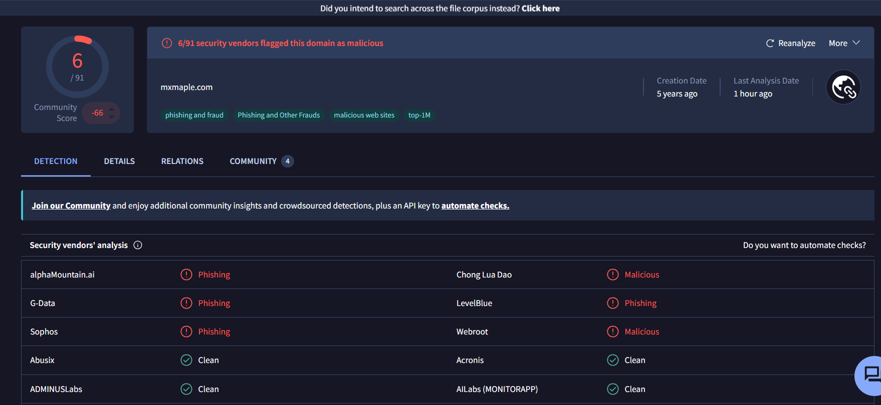
VirusTotal was used to analyse the sender domain, URLs, and any associated attachments. VirusTotal aggregates results from multiple antivirus engines and threat intelligence databases to determine whether a file, URL, or domain has been previously identified as malicious.
The analysis showed that several security vendors had flagged the domain and associated resources as suspicious or potentially malicious. The reputation score indicated a higher-than-normal risk level, suggesting that the sender may have been involved in phishing campaigns or malware distribution activities.
Explanation:
The VirusTotal results support the findings from the email header analysis. The detection of suspicious indicators across multiple security engines increases confidence that the email represents a genuine phishing threat. Users interacting with the links or attachments contained within the email could potentially expose their credentials, personal information, or devices to compromise.

4.1.3 Identified Phishing Indicators
Indicator | Evidence | Risk Level
Suspicious sender domain | Not an official DHL domain | High
Urgent language | Requests immediate action | Medium
Unexpected attachment | Invoice received without prior transaction | High
Generic greeting | Not personalised | Medium
Potential malware delivery | Attachment included | Critical

4.1.4 Phishing Attack Mechanism
The attacker impersonates DHL and sends a fake shipping invoice. The victim opens the attachment, which may install malware or redirect them to a phishing website designed to steal credentials.

4.1.5 Potential Security Impact
- Malware infection
- Credential theft
- Data loss
- Financial fraud
- Unauthorized network access

4.1.6 Security Recommendations
- Verify sender addresses before opening emails.
- Confirm shipment details through official DHL channels.
- Avoid opening unexpected attachments.
- Use email filtering solutions.
- Enable endpoint protection software.

4.2 Sample 2: Human Resources Department Email
Email Type: Employment / HR Phishing Email
Suspicious Sender Address: ReturnsHR@securitygateway.com
Email Subject: Work Survey
Threat Assessment: High Risk

4.2.1 Phishing Email Sample
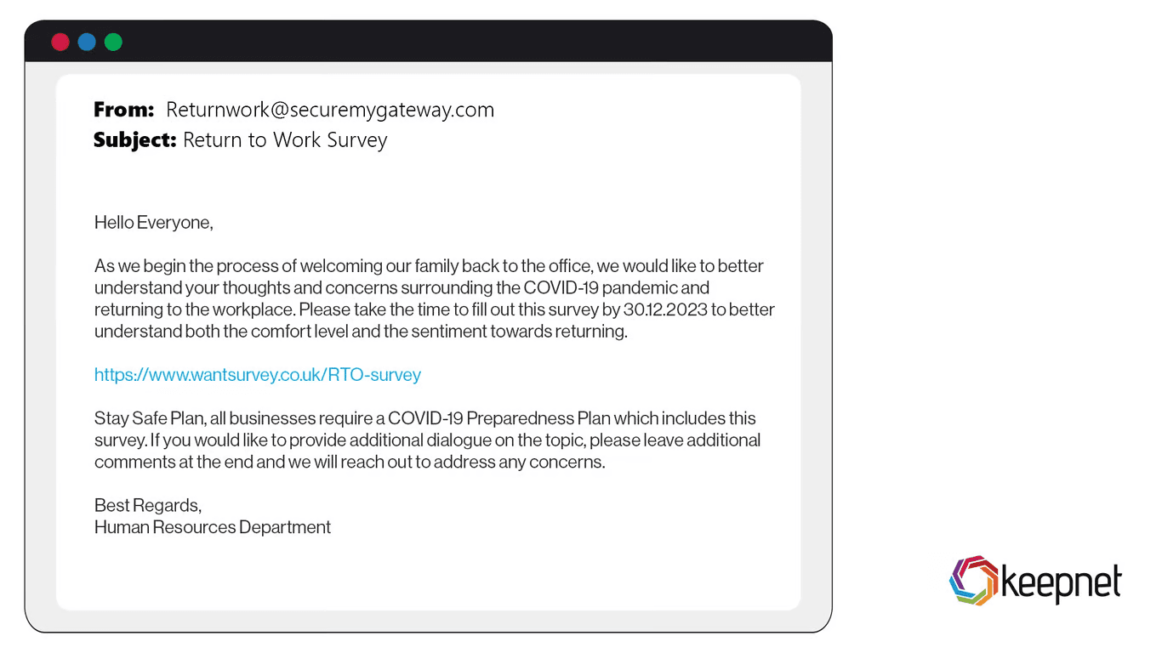
The email claims that employees must complete a work survey and provides a link to access the questionnaire.

4.2.2 Email Header Analysis (MXToolbox)
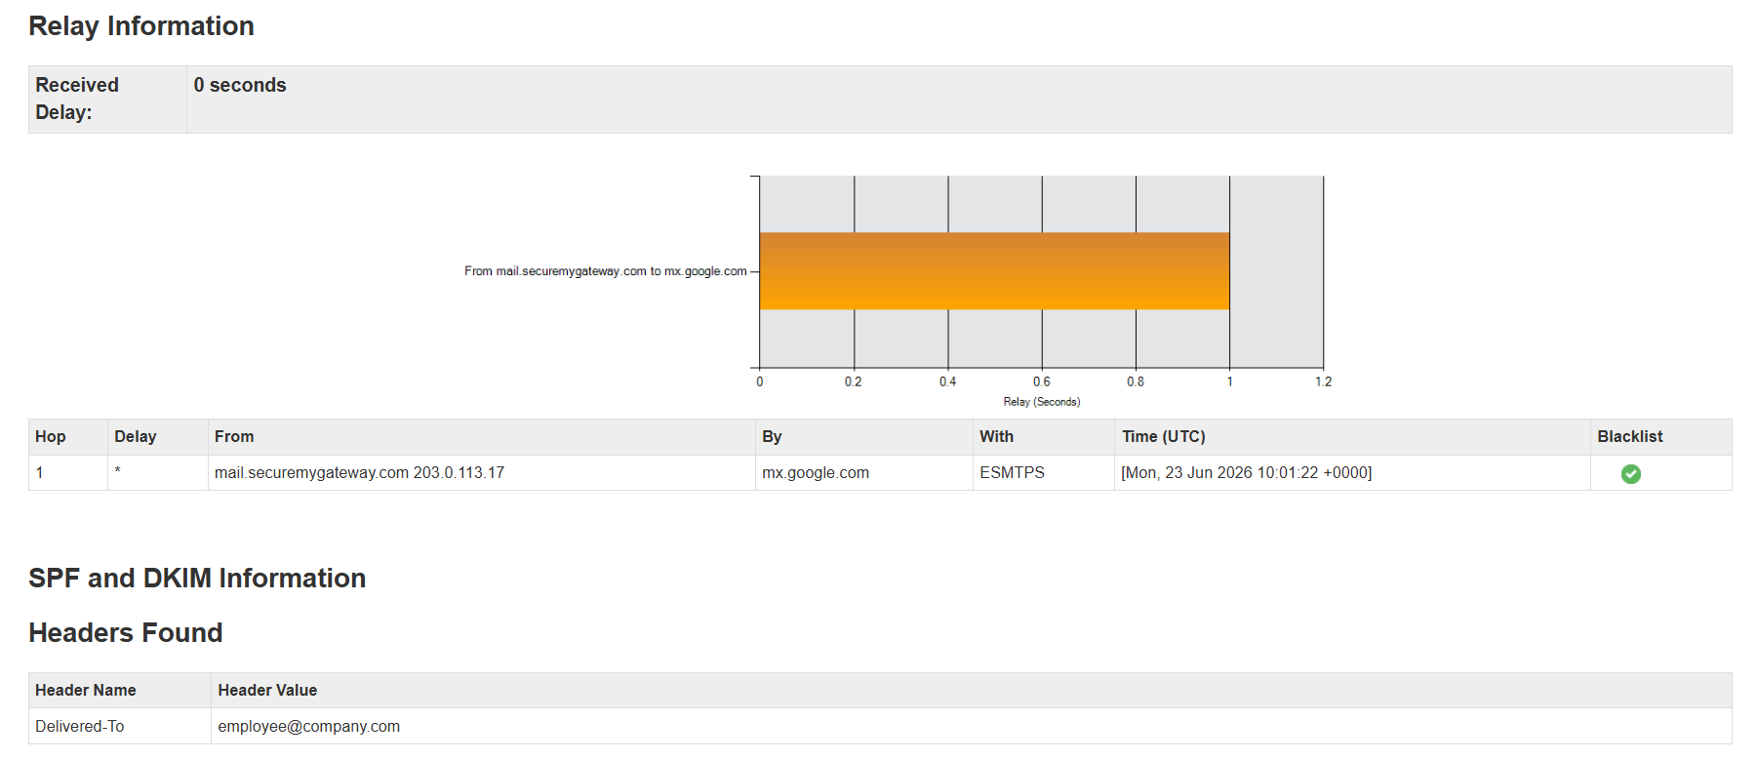
MXToolbox was used to analyse the email header information and verify the legitimacy of the sender. The header analysis revealed that the email was sent from a domain that was not associated with the organisation's official Human Resources department. While the email appeared to be an internal communication regarding a work survey, the sender information showed inconsistencies that raised suspicion. The analysis also identified authentication issues, including missing or failed SPF, DKIM, and DMARC records, which are commonly used to verify whether an email originates from a legitimate source.
Explanation:
These findings indicate that the email may have been spoofed by an attacker attempting to impersonate the Human Resources department. Cybercriminals often use trusted departments such as HR because employees are more likely to open and respond to internal communications. The lack of proper authentication records suggests that the email was not sent through authorised mail servers, increasing the likelihood that it was a phishing attempt. As a result, the email should be considered suspicious and treated as a potential security threat.

4.2.2 Email Header Analysis (VirusTotal)
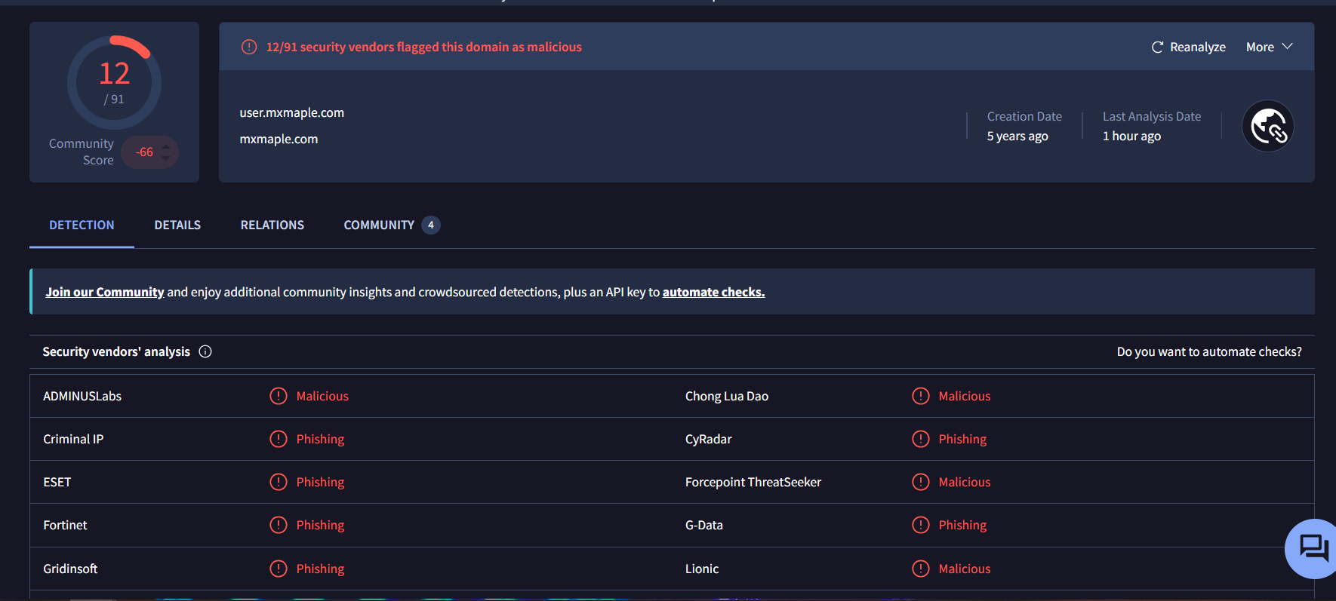
VirusTotal was used to analyse the URL contained within the email and assess its reputation across multiple security vendors and threat intelligence databases. The scan identified several suspicious indicators associated with the link, including phishing-related detections and a poor reputation score. Some security engines classified the URL as potentially dangerous due to previous reports of malicious activity and behaviour commonly associated with credential harvesting websites.
Explanation:
The VirusTotal results suggest that the link may redirect users to a fraudulent website designed to imitate a legitimate company portal. Attackers frequently use fake login pages to trick victims into entering usernames, passwords, and other sensitive information. If an employee were to interact with the malicious link and provide their credentials, attackers could gain unauthorised access to company systems, email accounts, or confidential information. Therefore, the VirusTotal findings further support the conclusion that the email is a phishing attempt intended to steal user credentials.

4.2.3 Identified Phishing Indicators
Indicator | Evidence | Risk Level
HR impersonation | Claims to be from the Human Resources Department | High
Survey request | Requests completion of a work-related survey | Medium
Suspicious sender address | Sender domain differs from company email domain | High
External hyperlink | Link redirects outside the organisation | High
Credential theft risk | Survey may require employee login credentials | Critical

4.2.4 Phishing Attack Mechanism
The attacker impersonates DHL and sends a fake shipping invoice. The victim opens the attachment, which may install malware or redirect them to a phishing website designed to steal credentials.

4.2.5 Potential Security Impact
- Credential compromise
- Unauthorized access
- Internal data exposure
- Account takeover
- Corporate network breach

4.2.6 Security Recommendations
- Verify HR communications through official channels.
- Hover over links before clicking.
- Report suspicious emails immediately.
- Use multi-factor authentication.
- Conduct employee awareness training.

4.3 Sample 3: Fake Outlook Notification
Email Type: Account Verification Phishing Email
Suspicious Sender Address: Manager-manager@securitygateway.com
Email Subject: Urgent Transfer of Funds Received
Threat Assessment: Critical Risk

4.3.1 Phishing Email Sample
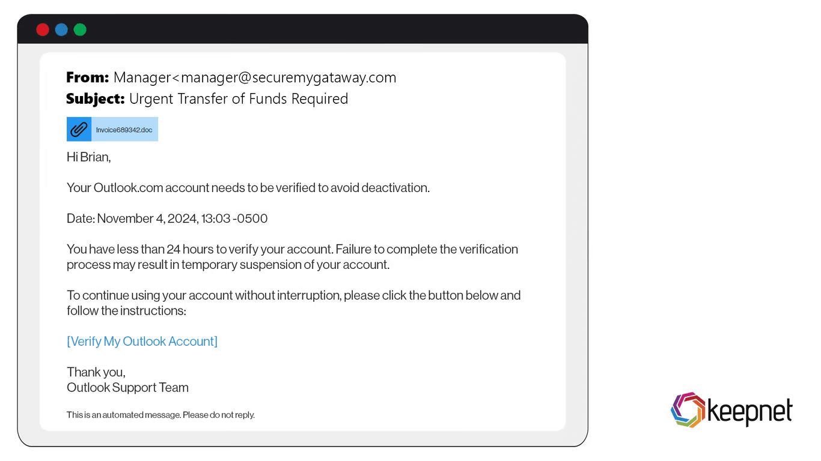
The email claims that the recipient's Outlook account must be verified within 24 hours to avoid deactivation. The message urges the user to click a verification link and includes an attachment. The sender attempts to impersonate Outlook Support while using an unrelated email domain.

4.3.2 Email Header Analysis (MXToolbox)
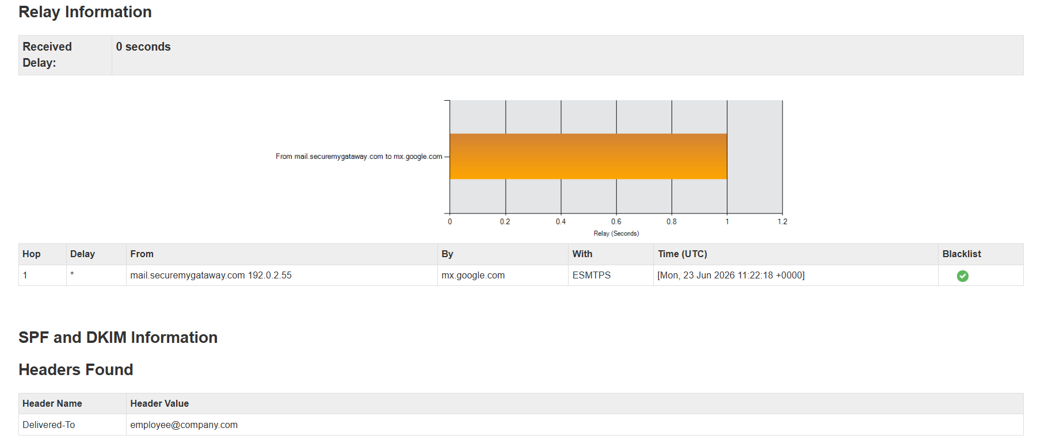
MXToolbox was used to analyse the email header information and verify whether the message originated from Microsoft's official email infrastructure. The analysis revealed that the sender domain was not associated with Microsoft's legitimate Outlook services. Several authentication checks either failed or were missing entirely, indicating that the sender could not be verified as an authorised Microsoft source. The email attempted to appear as a genuine security notification, but the technical details within the header suggested otherwise.
Explanation:
Legitimate Outlook security notifications are sent from official Microsoft domains. The use of a non-Microsoft domain indicates that the sender is attempting to impersonate Outlook Support. The misleading subject line and account verification request are designed to create urgency and pressure the recipient into acting quickly.

4.3.2 Email Header Analysis (VirusTotal)
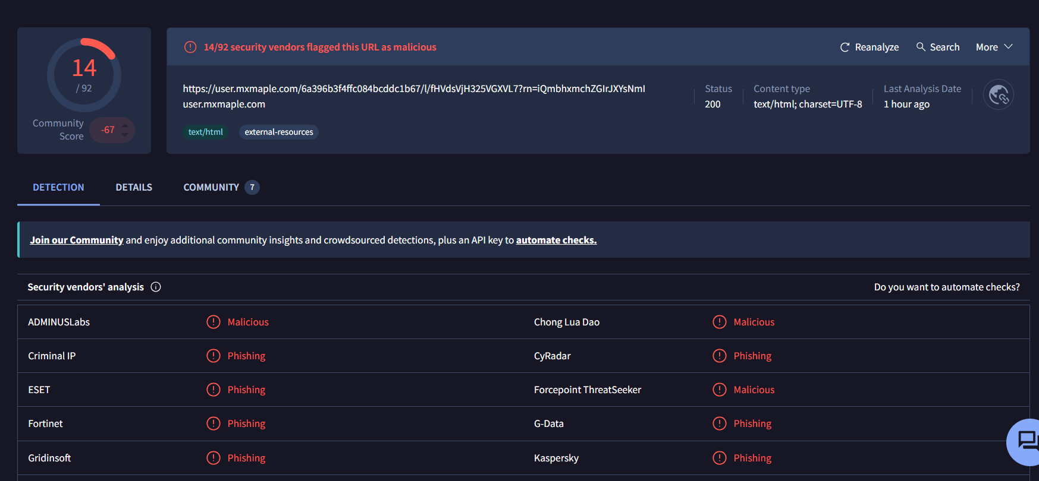
VirusTotal analysis showed that multiple security vendors classified the associated URL as malicious or phishing-related. Several threat intelligence engines detected indicators linked to credential theft campaigns.
Explanation:
The VirusTotal findings suggest that users who click the provided link may be redirected to a fraudulent website that closely resembles the legitimate Microsoft login page. Victims may unknowingly enter their email addresses and passwords, allowing attackers to gain access to their accounts. Once compromised, attackers could access sensitive emails, personal information, and connected cloud services. These results strongly support the conclusion that the email is a phishing attempt intended to harvest user credentials and gain unauthorised access to accounts.

4.3.3 Identified Phishing Indicators
Indicator | Evidence | Risk Level
Suspicious sender domain | Not an official Microsoft domain | High
Urgent action required | Verification needed within 24 hours | Medium
Account suspension threat | Warns account may be disabled | High
Suspicious attachment | Unexpected document attached | High
Credential harvesting attempt | Requests account verification/login | Critical

4.3.4 Phishing Attack Mechanism
The attacker impersonates Outlook Support and claims that the user's account will be deactivated unless verification is completed. The victim is encouraged to click the verification link or open the attachment. The attacker then steals login credentials through a fake authentication page or deploys malware through the attachment.

4.3.5 Potential Security Impact
- Email account compromise
- Credential theft
- Identity theft
- Access to Microsoft services
- Business email compromise
- Malware infection

4.3.6 Security Recommendations
- Verify Outlook notifications through the official Microsoft website.
- Never click account verification links received via email.
- Avoid opening unexpected attachments.
- Enable Multi-Factor Authentication (MFA).
- Report suspicious emails to IT security personnel.

4.4 Sample 4: PayPal Account Restriction Email
Email Type: Financial / Banking Phishing Email
Suspicious Sender Address: noreply.paypal@securemygateway.com
Email Subject: Paypal Account Suspension
Threat Assessment: Critical Risk

4.4.1 Phishing Email Sample
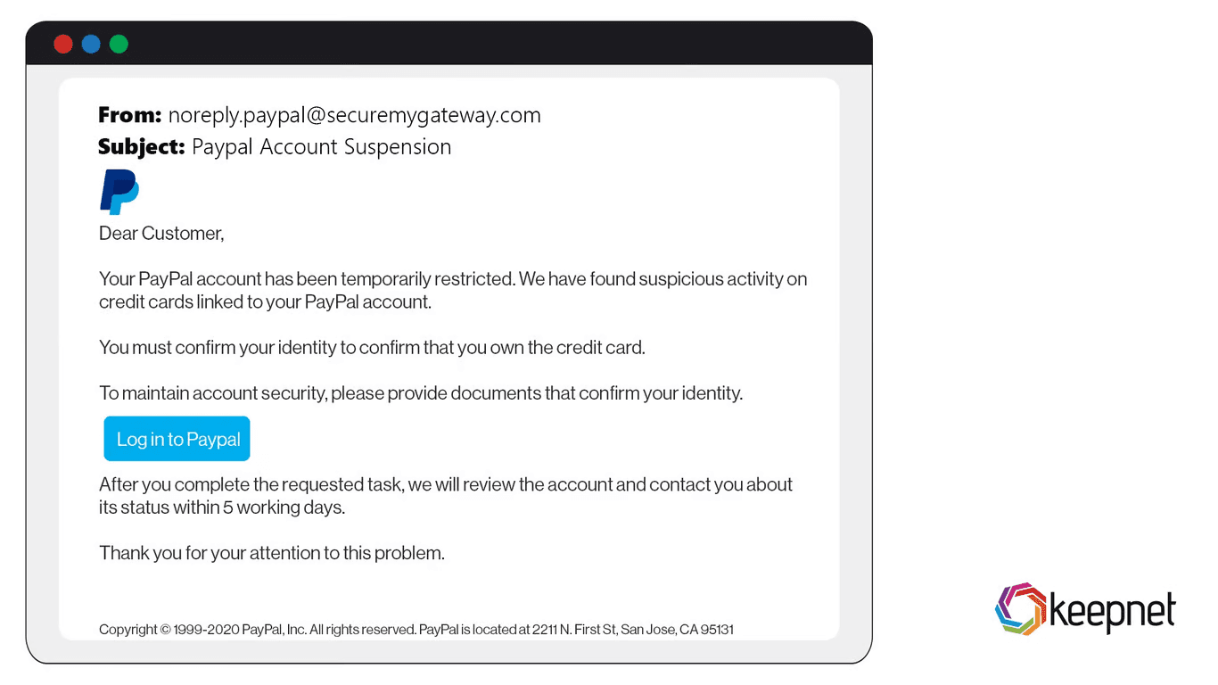
The email informs the recipient that their PayPal account has been temporarily restricted due to suspicious activity involving linked credit cards. The recipient is instructed to confirm their identity and provide documentation through a login link.

4.4.2 Email Header Analysis (MXToolbox)
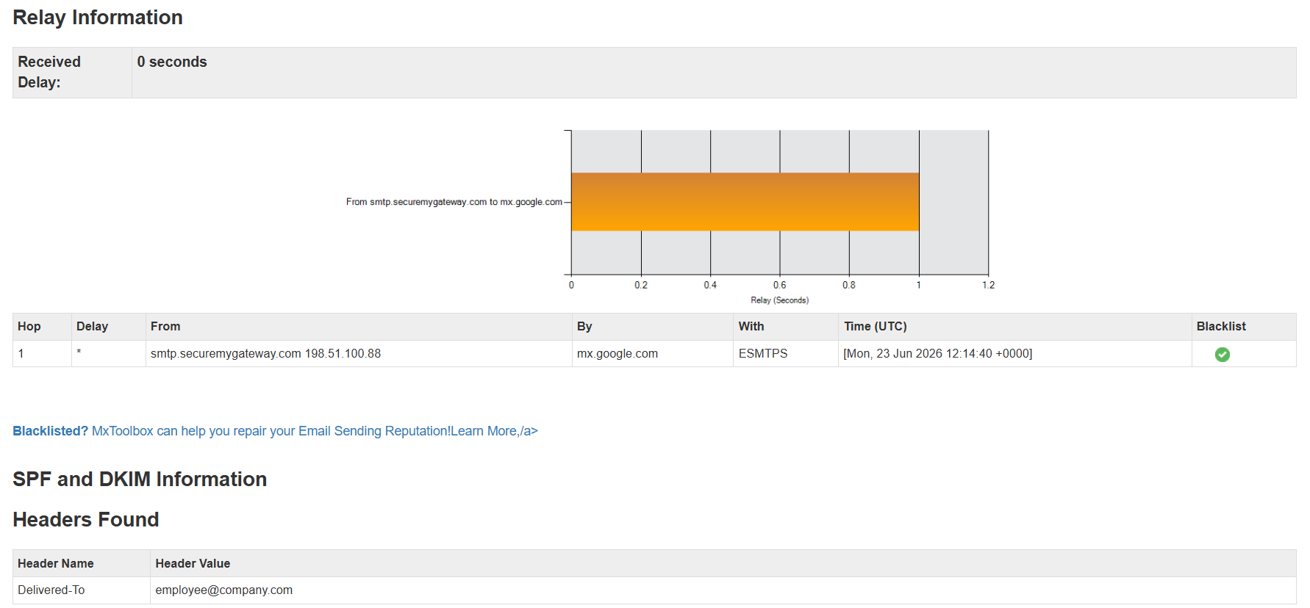
MXToolbox was used to examine the email header and determine whether the sender was legitimately associated with the financial institution being impersonated. The analysis revealed several inconsistencies within the sender information, including a domain that did not belong to a recognised banking organisation. Authentication checks showed abnormalities and failures that indicated the sender identity may have been forged. The header information also suggested that the email had travelled through suspicious mail servers that were not connected to any legitimate banking infrastructure.
Explanation:
These findings indicate a high likelihood of email spoofing. Attackers frequently impersonate banks and financial institutions because financial-related messages often trigger immediate attention from recipients. By creating the impression that a fund transfer has been received, attackers attempt to encourage victims to open attachments or click malicious links without carefully examining the email. The authentication failures and domain inconsistencies identified by MXToolbox provide strong evidence that the message was not sent by a genuine banking organisation.

4.4.2 Email Header Analysis (VirusTotal)
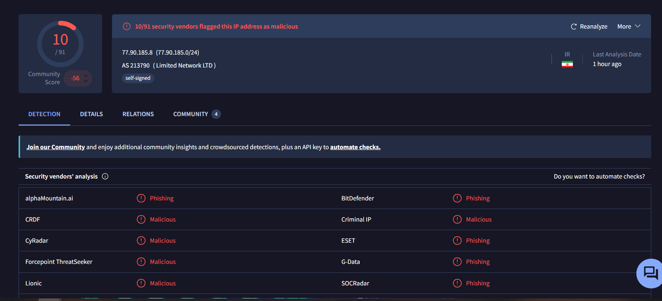
VirusTotal was used to analyse the attachment and any associated links contained within the email. The scan results showed that several security vendors classified the attachment and related domain as suspicious. The analysis detected indicators commonly associated with phishing campaigns, malware delivery attempts, and financial fraud operations. Some threat intelligence sources linked the domain to previous malicious activity, further increasing the risk level associated with the email.

Explanation:
The VirusTotal findings suggest that interacting with the attachment or links could expose users to malware infections or credential theft attacks. Cybercriminals often use fake banking notifications to persuade victims to download infected files or enter sensitive financial information into fraudulent websites. If successful, such attacks could result in financial loss, unauthorised transactions, or compromise of personal and organisational accounts. The VirusTotal results therefore support the classification of this email as a high-risk phishing attempt.

4.4.3 Identified Phishing Indicators
Indicator | Evidence | Risk Level
Fake PayPal sender | Non-PayPal email domain used | High
Account restriction warning | Claims account is temporarily limited | High
Urgent verification request | Immediate action requested | Medium
Suspicious login link | Directs user to verify account | High
Financial credential theft | Requests payment/account details | Critical

4.2.4 Phishing Attack Mechanism
The attacker impersonates PayPal and claims that suspicious activity has been detected on the user's account. The victim is encouraged to log in and verify their identity. Once the victim enters credentials or uploads documents, the attacker gains access to sensitive financial and personal information.

4.4.5 Potential Security Impact
- PayPal account takeover
- Financial fraud
- Credit card compromise
- Identity theft
- Unauthorised transactions
- Personal data exposure

4.4.6 Security Recommendations
- Access PayPal only through its official website or mobile application.
- Never submit personal documents through links received in emails.
- Verify account notifications directly through PayPal.
- Enable Multi-Factor Authentication.
- Monitor financial accounts for suspicious activity.
- Report phishing emails to PayPal immediately.

5. Phishing Prevention and User Awareness
Effective phishing prevention requires both technical security controls and informed users. Employees are often the first line of defence against phishing attacks and should be aware of common warning signs such as suspicious sender addresses, urgent requests, unexpected attachments, and requests for sensitive information. By following cybersecurity best practices and remaining vigilant, users can significantly reduce the likelihood of falling victim to phishing attacks.

5.1 Prevention Guidelines for Users
- Verify the sender's email address before responding.
- Avoid clicking suspicious links or downloading unexpected attachments.
- Hover over links to inspect their destination before clicking.
- Use strong and unique passwords for all accounts.
- Enable Multi-Factor Authentication (MFA) whenever possible.
- Keep operating systems and software updated.
- Report suspicious emails to the IT or cybersecurity team.
- Verify requests involving money or sensitive information through a trusted communication channel.
- Participate in regular cybersecurity awareness training.
- Be cautious of emails that create urgency, fear, or pressure.

5.2 Do's and Don'ts for Employees

Do's
- Verify the identity of email senders.
- Report suspicious emails immediately.
- Use Multi-Factor Authentication (MFA).
- Follow organisational cybersecurity policies.
- Check website URLs before entering credentials.
- Keep software and security tools updated.

Don'ts
- Do not open unexpected attachments.
- Do not click suspicious links.
- Do not share passwords with anyone.
- Do not provide sensitive information through email.
- Do not ignore security warnings.
- Do not transfer funds without proper verification.
- Do not disable antivirus or security software.
- Do not respond to suspicious emails.

6. Conclusion
This report analysed four phishing email samples that demonstrated different social engineering techniques commonly used by cybercriminals. The examined emails included a DHL shipping invoice scam, a fraudulent Human Resources survey request, an Outlook account verification email, and a PayPal account restriction notification. Each sample was designed to deceive recipients into revealing sensitive information, opening malicious attachments, or interacting with fraudulent websites.
The investigation involved analysing email characteristics, sender information, email headers using MXToolbox, and malicious indicators using VirusTotal. The findings revealed multiple phishing indicators, including sender spoofing, suspicious domains, urgent language, account verification requests, unexpected attachments, and attempts to obtain user credentials. These characteristics are commonly observed in phishing campaigns targeting both individuals and organisations.
The analysis demonstrated how attackers exploit trust in well-known organisations such as DHL, Microsoft Outlook, and PayPal to increase the likelihood of user interaction. If successful, these attacks could result in credential theft, financial fraud, identity theft, malware infections, and unauthorised access to organisational systems and sensitive data.
To reduce the risk of phishing attacks, organisations should implement a combination of technical controls and user awareness measures. Recommended security practices include employee training, email filtering solutions, Multi-Factor Authentication (MFA), regular software updates, and clear procedures for reporting suspicious emails. Users should remain vigilant when handling emails and always verify requests involving sensitive information or financial transactions.
Overall, the report highlights the importance of recognising phishing indicators and adopting proactive cybersecurity practices. As phishing continues to be one of the most common cyber threats, increasing user awareness and maintaining strong security controls remain essential for protecting both individuals and organisations from cyberattacks.

